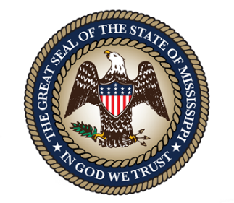
STATE OF MISSISSIPPI
DEPARTMENT OF AGRICULTURE AND COMMERCE
ANDY GIPSON
COMMISSIONER
MEDIA ADVISORY
FOR IMMEDIATE RELEASE: February 13, 2026

Contact: Hannah East, Communications Director
(601) 359-1179 / cell: (662) 816-3230
HannahE@mdac.ms.gov

What: 61st Dixie National Livestock Show and Rodeo

When: Saturday, February 14, and Sunday, February 15

Where: Mississippi State Fairgrounds

Schedule of 61st Annual Dixie National Livestock Show and Rodeo Events Taking Place
Tomorrow, Saturday, February 14, and Sunday, February 15

STATE FAIRGROUNDS, Miss. – Commissioner of Agriculture and Commerce Andy Gipson invites everyone to attend the 61st annual Dixie National Livestock Show and Rodeo and announces the schedule of events taking place tomorrow, Saturday, February 14, and Sunday, February 15. All events take place on the Mississippi State Fairgrounds.

The Dixie National Parade rides through downtown Jackson on Saturday, February 14, at 10:30 a.m. This beloved event that traditionally kicks off rodeo competitions will include an array of rodeo queens, marching bands, decorative floats, car and tractor clubs, riding groups, the famous Dixie National Wagon Train and more. Beginning at the corner of Mississippi and Jefferson streets, the procession will travel down Mississippi Street, circle the State Capitol, and finally take a left onto Amite Street before returning to the State Fairgrounds. Spectators are encouraged to watch from the Capitol grounds near President, High and West streets for the best views. Parking will be available at the Capitol grounds and surrounding parking lots.

The Dixie National Marketplace will continue through the weekend inside the Trade Mart. This massive expo is open to the public with no admission fee. Attendees will be able to find a variety of western and rodeo themed clothing and accessories, items for the farm like tractors and trailers, and specialty foods.

Rodeo fans can enjoy two rodeo performances tomorrow, February 14, at 2:00 p.m. and 7:00 p.m. Up-and-coming artist Bayker Blankenship with his hit “Maxed Out” will perform following both Rodeo performances. Sunday, February 15, following the action-packed Rodeo at 2:00 p.m., legendary Joe Nichols will perform. His hits include “Tequila Makes Her Clothes Fall Off,” “Brokenheartsville” and “Sunny and 75.”

A variety of Open Livestock Shows featuring cattle and swine will be taking place in Barns 6 and 14 throughout the weekend. These shows are open to all ages with some competitors traveling to Mississippi to compete.

Scheduled Activities & Events for Saturday, February 14, 2026:
- 7:30 a.m. - 10:30 a.m. – Dixie National Rodeo Breakfast - Red Barn near Barn 16
- 7:30 a.m. – Intercollegiate Beef Judging Contest - Equine Center
- 8:00 a.m. – Open Santa Gertrudis Show - Barn 14
- 10:00 a.m. - 7:00 p.m. – Dixie National Marketplace - Trade Mart
- 10:30 a.m. – Dixie National Parade - Corner of Mississippi and President Streets (downtown Jackson)
- 11:00 a.m. - 7:00 p.m. – Dixie National Steakhouse - Trade Mart
- 2:00 p.m. – Dixie National Rodeo featuring Bayker Blankenship - Coliseum
- 2:00 p.m. – Open Brangus Show - Barn 14
- 7:00 p.m. – Dixie National Rodeo featuring Bayker Blankenship - Coliseum
- 10:00 p.m. – Dixie National Afterparty - Martin’s Downtown

Scheduled Activities & Events for Sunday, February 15, 2026:
- 9:00 a.m. – Open Beefmaster Show - Barn 14
- 15 minutes after Beefmaster Show – Open Braford/F1 Show - Barn 14
- 9:00 a.m. – Open Advancer/E6 Show - Barn 14
- 9:00 a.m. – Open Barrow Swine - Swine Arena/Barn 6
- 9:00 a.m. – Open Swine Show - Swine Arena/Barn 6
- 10:00 a.m. - 5:00 p.m. – Dixie National Marketplace - Trade Mart
- 11:00 a.m. - 7:00 p.m. – Dixie National Steakhouse - Trade Mart
- 2:00 p.m. – Dixie National Rodeo featuring Joe Nichols - Coliseum

In conjunction with the nationwide America250 celebrations, this year’s Dixie National will take on a special patriotic focus. Events of the 61st Dixie National Livestock Show and Rodeo run through Sunday, February 22, 2026. The Dixie National Rodeo, the largest rodeo east of the Mississippi River, runs through Saturday, February 21, inside the Mississippi Coliseum at the State Fairgrounds.

Rodeo Entertainment:
- Saturday, February 14, at 2:00 p.m. and 7:00 p.m. – Bayker Blankenship
- Sunday, February 15, at 2:00 p.m. – Joe Nichols
- Wednesday, February 18, at 7:00 p.m. – Tanya Tucker
- Thursday, February 19, at 7:00 p.m. – Waylon Wyatt
- Friday, February 20, at 7:00 p.m. – Muscadine Bloodline
- Saturday, February 21, at 2:00 p.m. and 7:00 p.m. – Mark Chesnutt

To purchase tickets to the Dixie National Rodeo, visit www.ticketmaster.com/search?q=dixie+national+rodeo online or the Coliseum Box Office in-person. For more information on the Dixie National Livestock Show and Rodeo, visit www.dixienational.org and follow the Dixie National Livestock Show & Rodeo on Facebook, Instagram and X.
###

Photo attached.

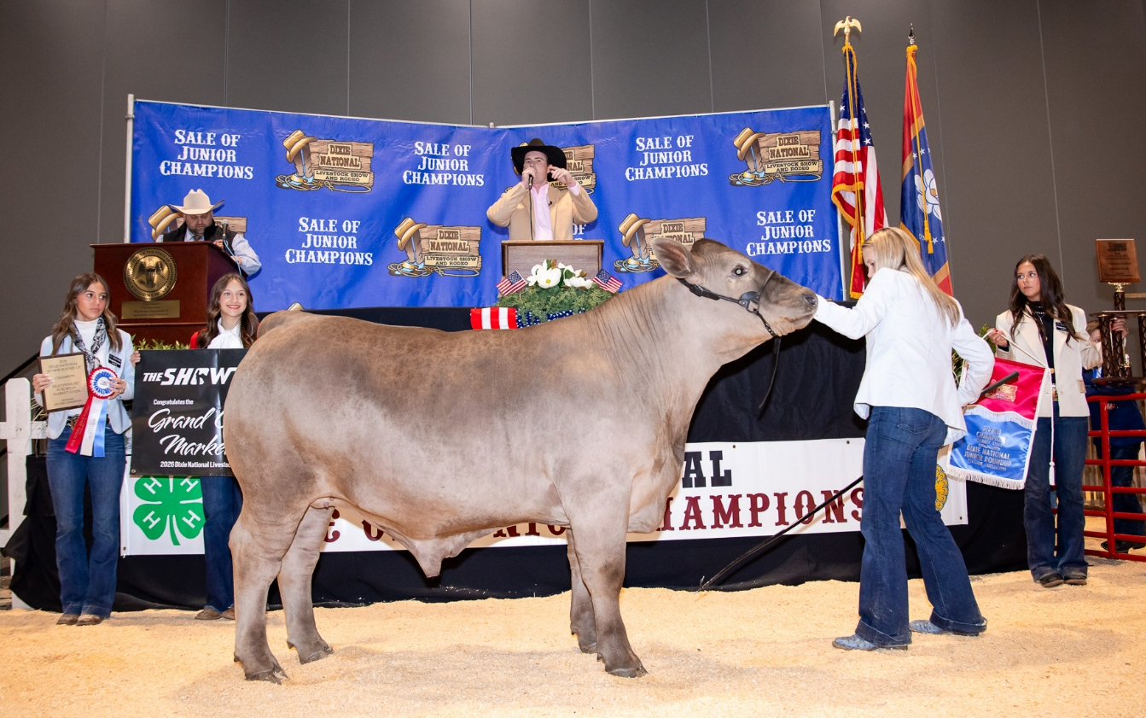
The 57th Annual Sale of Champions was one for the record books. This week, 40 animals were sold for a total of $578,050, the second highest sale on record. Forty-one scholarships totaling $85,000 were also awarded. The Sale of Junior Champions is one of the premier events of the Dixie National Livestock Show and Rodeo. During the sale, 4-H and FFA youth exhibitors named Champions and Reserve Champions in the Junior Round-Up, auction off their prize-winning livestock.

MEDIA NOTE:
A designated Media Room will be available to local/state newspapers, tv stations and print and broadcasting media for the Dixie National Rodeo, which takes place February 13-15 and 18-21. Media will have access to live updates/stats from each rodeo performance, current leaderboard information and exclusive one-on-one interviews with rodeo competitors and entertainers. The media room, or Gray Room, is located on the south side of the Coliseum. To enter the Coliseum, simply show your work ID badge at the doors. Enter the Coliseum through the glass doors on the south side and take an immediate right. The media room will be on your right. The room is easily visible and will be labeled MEDIA ROOM.
Media passes will be distributed in the Media Room for those who want to get b-roll footage inside the Coliseum arena. You will be directed to the reserved section designated for your camera crews. We will bring cowboys/clowns/queens/etc. to the media room for interviews. If there are specific people that you would like to interview for a story, let us know ahead of time and we will work to make those happen.
Immediately following each rodeo performance, a rodeo announcer will be in the Media Room to provide a Rodeo Recap to the media.
If members of the media would like to request interviews regarding Dixie National Livestock Show and Rodeo events, please contact Hannah East at hannahe@mdac.ms.gov or (662) 816-3230.

