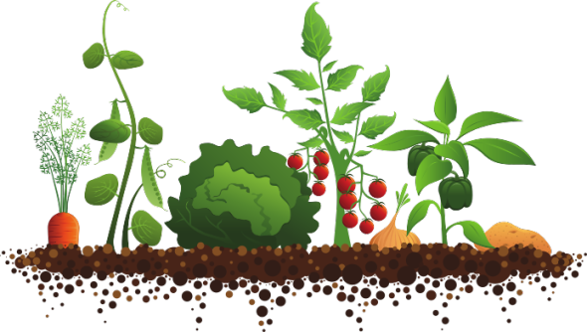

Let’s Plant

A Community Garden Grant Program

Program Year: 2024-2025

What is Let’s Plant?
Let’s Plant is a community garden grant program administered through the Mississippi Department of Agriculture and Commerce with the USDA Specialty Crop Block Grant Program. Let’s Plant is an educational tool to enhance the knowledge of communities on agriculture, healthy eating and where food comes from. As society becomes increasingly removed from agricultural practices and the farm, it remains pertinent to educate communities on the origin of their food.

Who is Eligible?
Community organizations, non-profits, and city/county governments in the state of Mississippi are eligible to apply. Grants cannot be awarded to an individual. Communities are eligible to apply to further expand an existing community garden or to request funds to create a community garden. It is encouraged that communities applying have local support, for example, a local extension office or Master Gardeners. This program is on a first come, first serve basis.

Criteria/Reporting Requirements
Communities interested in applying should note that there will be necessary reporting to achieve results required by MDAC.

The following criteria must be met:
- Garden must be located in a common or community area. It cannot be located on personal, residential property.
- At a minimum, garden must include involvement from at least 10 citizens.
- Extension Service, Master Gardeners, and /or Farmer involvement is strongly encouraged.
- The garden grant can only reimburse expenses for supplies for a specialty crop garden, see “Allowable Purchases” below.
- Produce from gardens may be consumed or donated. Produce cannot be sold for profit.

Communities and that receive funds will be required to track the number of participants involved and track those that increased knowledge of specialty crops by a survey conducted prior to and after garden grant activities.

At the end of the grant, MDAC will require the following:
- Number of adults involved: ________
- Number of volunteers involved:______
- Take appropriate surveys pre- and post- garden activities to be able to provide this information:
  - Of the _____ (number) total number of adults reached, _____ (number) that gained knowledge about eating more specialty crops.

Example: Of the 150 total number of adults reached, 100 gained knowledge about eating more specialty crops.

Allowable Purchases/Awarded Grants
Only specialty crops can be planted in gardens that are utilizing these funds. Specialty crops are defined in law as “fruits and vegetables, tree nuts, dried fruits, and horticulture and nursery crops, including floriculture.” Below is a list of allowable purchases through this grant program; supplies not listed below should obtain approval from MDAC before purchasing.

Grant funds may be used to purchase materials such as:
- Seeds or plants for fruit, vegetable, herb, and/or flower production
- Mulch/Soil
- Materials for stakes, raised bed gardens, etc.
- Planting tools-rakes, shovels, etc.
- Watering hoses
- Harvesting containers, buckets, etc.
- Gloves
- Fertilizers

MDAC will disperse grant funds on a reimbursement basis to the community applicant (funds cannot be reimbursed to an individual). Reimbursements will be made on an as-needed basis, but requests for reimbursements should be made regularly and as soon as possible. A request for reimbursement should include: an invoice to MDAC with the amount requested; list of expenditures; and documentation of the expenditures (paid invoices, receipts, canceled checks, etc.).

In order to be paid from the State of Mississippi, you will need to setup a PayMode® account in addition to
registering in MAGIC (Mississippi’s Accountability System for Government Information and Collaboration).

Communities awarded garden grants will have until June 15, 2025, to expend their $750.

Program Contact
Susan Head Lawrence
Market Development Division
Mississippi Department of Agriculture and Commerce
P.O. Box 1609
Jackson, MS 39215
601-213-7542
susan@mdac.ms.gov

Andy Gipson, Commissioner
Let’s Plant | Garden Grant Application

Community Information
Community
Organization Applying
Street Address
City, ST, ZIP Code
Projected number of citizens participating
Where will garden be located in the community? (brief description)

Community Coordinator(s) Contact Information
Main Contact (Name)
Mailing Address
City, ST, ZIP Code
Phone
Best Time to Call
Email

Additional Volunteer(s)
Please provide us with names and contact information of those that will also be helping with the garden grant and if they are an extension agent, farmer, etc.
Name 1
Email/Phone 1
Name 2
Email/Phone 2
Name 3
Email/Phone 3
Name 4
Email/Phone 4
Name 5
Email/Phone 5
Name 6
Email/Phone 6

Funding Request/Project Plans

Amount of grant money applying for: $_______ (must match detailed budget breakdown)
Please create and provide the plan for the garden, including timeline of the project, crops to be planted, a detailed budget of estimated expenditures, and how this will impact the local community.

Example Timeline Template:
Please provide a timeline of activities, including who will be responsible and the dates or months the activity will take place. (Add more rows as needed)

Date(s) | Responsible Group | Project Activity

Example Budget Template:
Please provide a detailed list of supplies that will be purchased and a price estimate of each item. It is important that we understand how the budget will be utilized. (Add more rows as needed)

Budget Item | School Year(s) | Total
Supplies:
 | $ | $
 | $ | $
 | $ | $
 | $ | $
 | $ | $
 | $ | $
Total | $ | $

Justification of supplies requested:

List of specialty crops that will be planted and plan for crops harvested from the garden:

Reason for Applying:
Please provide the purpose of the proposed community garden and how it will impact the community:

I confirm that the location of community garden is not on personal, residential property:
- Yes
- No

Agreement and Signature

By submitting this application, I affirm that I am willing to care and maintain the garden throughout the year, should caretaker duties transfer to someone else; I will notify MDAC of the changes.
Name (printed)
Signature
Date

Return Completed Applications to:
Susan Head Lawrence
Market Development Division
Mississippi Department of Agriculture and Commerce
P.O. Box 1609
Jackson, MS 39215
susan@mdac.ms.gov

